1. Using a prior of

b0 <- matrix(c(0,0,0,0),nrow=4,ncol=1)

S0 <- matrix(0,nrow=4,ncol=4)

diag(S0) <- 5

We can implement the Probit Model and have the following result:

|  |  |  |  |  |  |
| --- | --- | --- | --- | --- | --- |
|  | mean | Median | Standard Deviation | 95%-lower | 95%-upper |
| 1 | 2.62 | 2.59 | 1.45 | -0.18 | 5.51 |
| age | -0.17 | -0.17 | 0.07 | -0.32 | -0.03 |
| Driving courses? | -0.63 | -0.64 | 0.52 | -1.63 | 0.4 |
| Like stats? | 0.71 | 0.71 | 0.52 | -0.31 | 1.74 |

We can see that larger age, having taken driving courses, and hates statistics tends to lead to lower risk in accidents in the past 6 months.

The trace plot of the betas are copied below which shows the convergence.

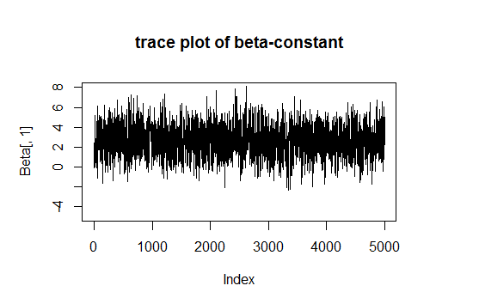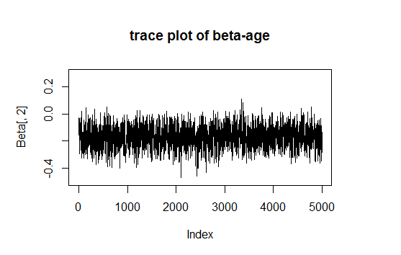

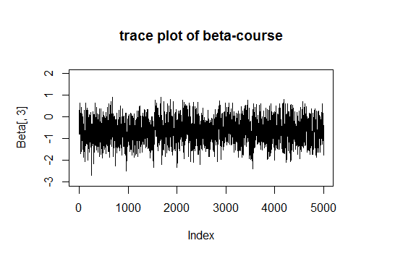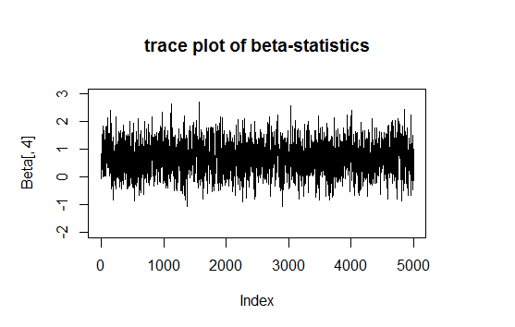

2. Using the Probit Regression Gibbs Sampling results, we can simulate the results of the two persons for each iteration. Comparing the expectation of simulation results, we can have the following table.

|  |  |  |
| --- | --- | --- |
|  | Person 1 | Person 2 |
| 1 | 1 | 1 |
| age | 17 | 18 |
| Driving courses | 1 | 1 |
| Like stats? | 0 | 1 |
| Probability of having an accident? | 21.4% | 37.8% |

Thus, we should pick ***person 1*** to park the car.

3. Implementing SSVS in the Model. S

|  |  |  |  |  |  |  |
| --- | --- | --- | --- | --- | --- | --- |
|  | mean | Median | Standard Deviation | 95%-lower | 95%-upper | Probability of Exclude this Predictor? |
| 1 | 0.77 | 0 | 1.57 | -1.16 | 4.2 | 0.32 |
| age | -0.06 | 0 | 0.09 | -0.25 | 0 | 0.58 |
| Driving courses? | -0.36 | 0 | 0.5 | -1.47 | 0.05 | 0.52 |
| Like stats? | 0.29 | 0 | 0.47 | 0 | 1.5 | 0.6 |
| s1 | -0.01 | 0 | 0.09 | -0.27 | 0.1 | 0.88 |
| s2 | 0.01 | 0 | 0.07 | -0.02 | 0.26 | 0.9 |
| s3 | 0 | 0 | 0.03 | 0 | 0.08 | 0.94 |

From the SSVS result we can see s1, s2, s3 has very high probability of being excluded from the Probit regression. Compared with the result using MCMC in problem 1, the 95% CI is more centered here.

We can also take a look at the trace plot of several betas:

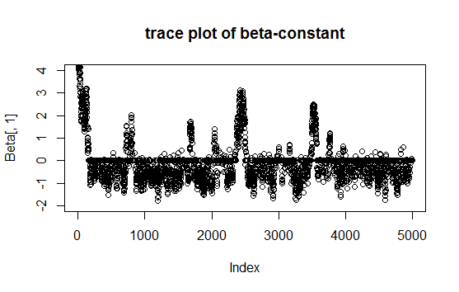 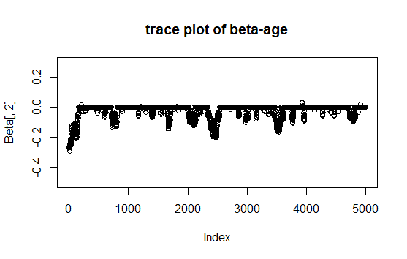

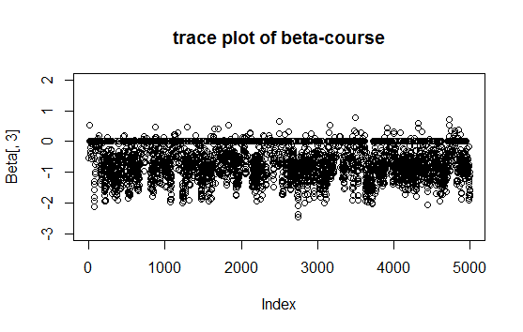 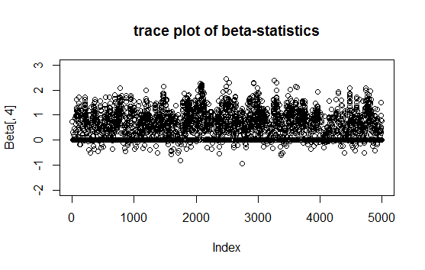

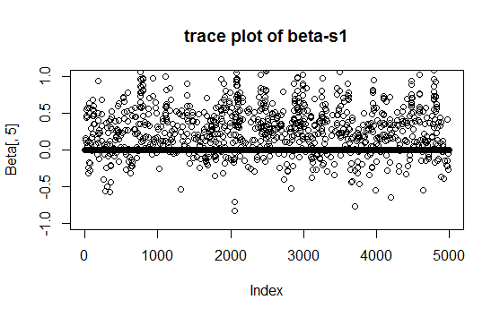 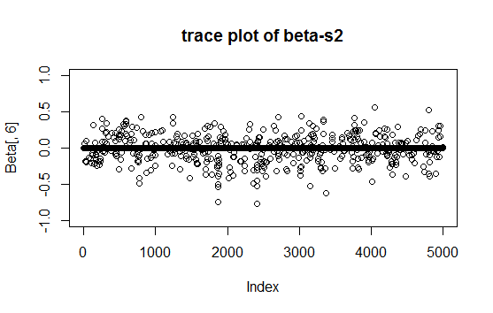

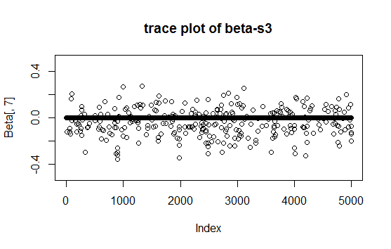

######Code

data <- read.csv("C:\\Users\\Dai\\Desktop\\Bayesian Statistics\\Lab Assignments\\12\\data.csv",header=T)

#data$age<- (data$age - mean(data$age))/sqrt(var(data$age))

library(mvtnorm)

X <- cbind(matrix(1,nrow=35,ncol=1),unlist(data[,1]),unlist(data[,2]),unlist(data[,3]))

y <- data[,4]

##Prior

b0 <- matrix(c(0,0,0,0),nrow=4,ncol=1)

S0 <- matrix(0,nrow=4,ncol=4)

diag(S0) <- 5

#Initials

beta <- b0

Sigma <- S0

n <- nrow(X)

z <- rep(0,n)

#Gibbs

T=5000

Beta <- matrix(nrow=T,ncol=4)

for (t in 1:T)

{

#latent variable z

eta<- X%*%beta

z[y==0]<- qnorm(runif(sum(1-y),0,pnorm(0,eta[y==0],1)),eta[y==0],1)

z[y==1]<- qnorm(runif(sum(y),pnorm(0,eta[y==1],1),1),eta[y==1],1)

#conditional distribution

Sigma.hat <- solve(solve(Sigma)+t(X)%*%X)

beta.hat <- Sigma.hat%*%(solve(Sigma)%*%b0+t(X)%*%z)

beta <- c(rmvnorm(1,beta.hat,Sigma.hat))

Beta[t,] <- beta

}

#output

table<- matrix(0,4,5)

for(i in 1:4){

table[i,]<- c(mean(Beta[,i]),median(Beta[,i]),sqrt(var(Beta[,i])),quantile(Beta[,i],c(0.025,0.975)))

}

table <- round(table*100)/100

write(t(table),file="betas.txt",ncol=5)

#plot

plot(Beta[,1],main="trace plot of beta-constant",type='l',ylim=c(-5,8))

plot(Beta[,2],main="trace plot of beta-age",type='l',ylim=c(-0.5,0.3))

plot(Beta[,3],main="trace plot of beta-course",type='l',ylim=c(-3,2))

plot(Beta[,4],main="trace plot of beta-statistics",type='l',ylim=c(-2,3))

######## Problem 2 #######

Input=t(matrix(c(1,17,1,0,1,18,1,1),nrow=4,ncol=2))

Output=pnorm(Input%*%t(Beta))

prob=rowMeans(Output)

print(prob)

########### Problem 3###########

library(mvtnorm)

data <- read.csv("C:\\Users\\Dai\\Desktop\\Bayesian Statistics\\Lab Assignments\\12\\data.csv",header=T)

library(mvtnorm)

X <- cbind(matrix(1,nrow=35,ncol=1),unlist(data[,1]),unlist(data[,2]),unlist(data[,3]))

s1=rnorm(dim(X)[1],0,1)

s2=rnorm(dim(X)[1],0,1.5)

s3=rnorm(dim(X)[1],0,2)

X <- cbind(X,matrix(s1,nrow=dim(X)[1],ncol=1),matrix(s2,nrow=dim(X)[1],ncol=1),matrix(s3,nrow=dim(X)[1],ncol=1))

y <- data[,4]

# Prior

p<- ncol(X)

p0<- rep(0.5,p)

b0<- rep(0,p)

s0<- rep(2,p)

# SSVS

#use mle estimate for beta's starting value

mle<- glm(y ~ -1+X, family=binomial("probit"))

beta.mle<- mle$coef

beta<- beta.mle

n<- nrow(X)

z<- rep(0,n)

T<- 5000

Beta <- matrix(nrow=T,ncol=p)

count <- matrix(0,ncol=p)

for(t in 1:T){

#latent variable

eta<- X%*%beta # linear predictor

z[y==0]<- qnorm(runif(sum(1-y),0,pnorm(0,eta[y==0],1)),eta[y==0],1)

z[y==1]<- qnorm(runif(sum(y),pnorm(0,eta[y==1],1),1),eta[y==1],1)

for(j in 1:p){

V<- 1/(s0[j]^{-2} + sum(X[,j]^2))

E<- V*sum(X[,j]*(z-X[,-j]%*%beta[-j]))

p.hat<- 1/(1 + p0[j]/(1-p0[j]) * dnorm(0,E,sqrt(V))/dnorm(0,b0[j],s0[j]) )

m<- rbinom(1,1,p.hat)

if (m==0) {count[j]=count[j]+1}

rbinom(1,1,p.hat)

beta[j]<- m*rnorm(1,E,sqrt(V))

}

# output results to a file for later processing

Beta[t,] <- matrix(beta,ncol=7)

}

plot(Beta[,1],main="trace plot of beta-constant",ylim=c(-2,4))

plot(Beta[,2],main="trace plot of beta-age",,ylim=c(-0.5,0.3))

plot(Beta[,3],main="trace plot of beta-course",,ylim=c(-3,2))

plot(Beta[,4],main="trace plot of beta-statistics",,ylim=c(-2,3))

plot(Beta[,5],main="trace plot of beta-s1",,ylim=c(-1,1))

plot(Beta[,6],main="trace plot of beta-s2",,ylim=c(-1,1))

plot(Beta[,7],main="trace plot of beta-s3",,ylim=c(-0.5,0.5))

#output

table<- matrix(0,7,6)

for(i in 1:7){

table[i,]<- c(mean(Beta[,i]),median(Beta[,i]),

sqrt(var(Beta[,i])),quantile(Beta[,i],c(0.025,0.975)),count[i]/T)

}

table <- round(table*100)/100

write(t(table),file="problem3.txt",ncol=6)